Configure YubiKey

Objective
Configure the YubiKey as a Passkey (security key) authentication method on the Contoso account, enabling access to VPN and other corporate resources without a password.

Prerequisites
- Physical YubiKey in hand
- Computer with a browser (Chrome, Edge, or Firefox)
- Contoso credentials (email @contoso.com and network password)

Step-by-Step
- Connect the YubiKey to the computer with the gold disc facing up.
- Access: https://mysignins.microsoft.com/security-info
- Click "+ Add Sign-In Method".
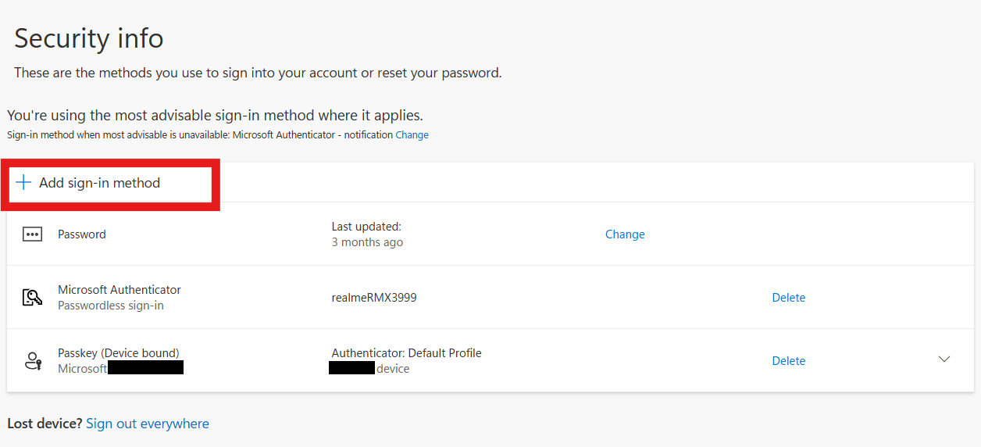
- With the "Add Sign-In Method" pop-up open, select PASSKEY.
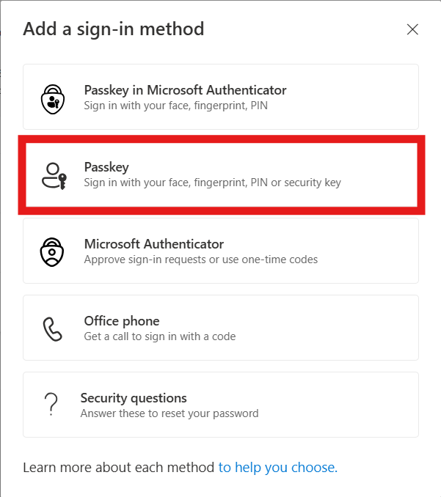
- On the next screen, click Next.
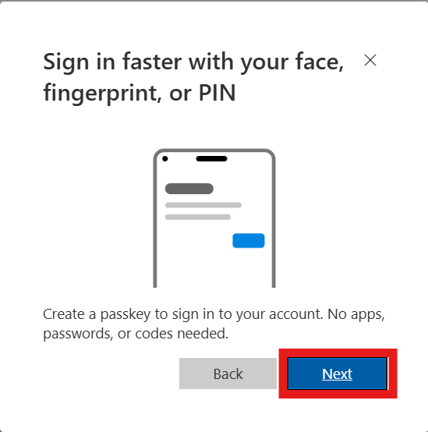
- Select "Use Another Device" and click Next.
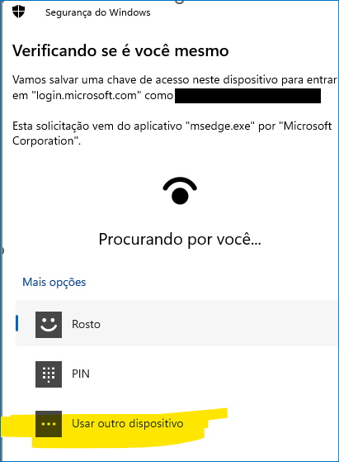
- Select "Security Key".
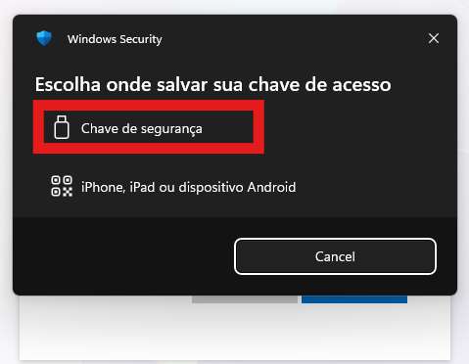
- Set a PIN with at least 4 digits and click "Next" or OK.
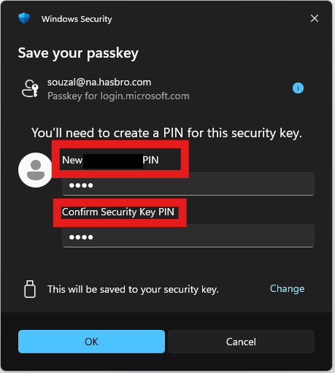
- When prompted, place your finger on the gold disc of the YubiKey (the Y indicator will start blinking green).
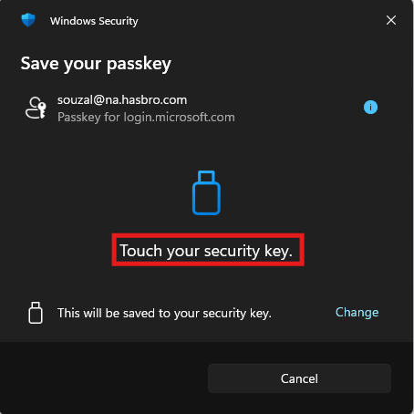
- When prompted, name the key as YubiKey.
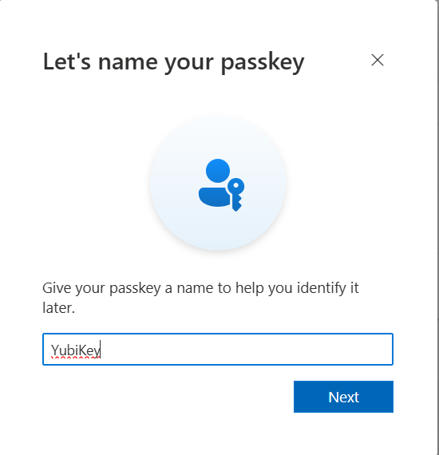
- Check at https://mysignins.microsoft.com/security-info whether the new method was added successfully.
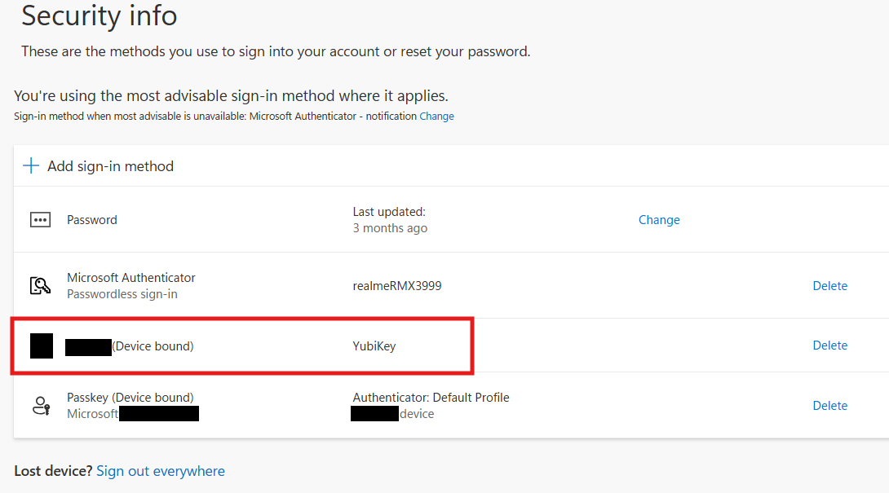

⚠ After configuration, test by connecting to the VPN to confirm everything is working correctly.

Version History
Author | Version | Date | Description
Lucas Souza | 1.0 | Jun/2026 | Document creation

